Golden Motor电机测试报告

电机型号(Type)： 3KW

单位名称(Company)： GOLDEN MOTOR 测试人(Tester)： 1

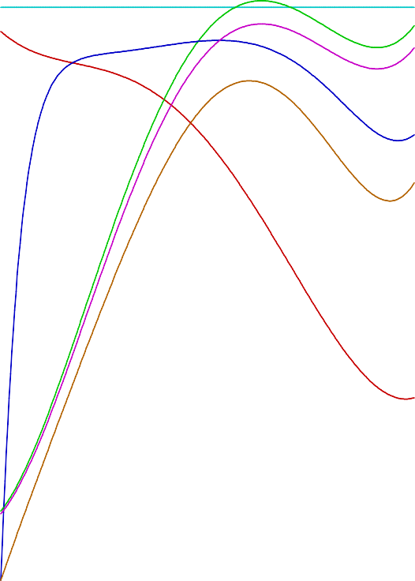测试日期(Test Date):2014-12-31

|  |  |  |  |  |  |  |  |  |  |
| --- | --- | --- | --- | --- | --- | --- | --- | --- | --- |
| V S |  |  | EF | I  Pin  F |  |  |  |  |  |
|  |  |  |  | Pout |  |  |  |  |  |
|  |  |  |  |  |  |  |  |  |  |
|  |  |  |  |  |  |  |  |  |  |
|  |  |  |  |  |  |  |  |  |  |
|  |  |  |  |  |  |  |  |  |  |
|  |  |  |  |  |  |  |  |  |  |
|  |  |  |  |  |  |  |  |  |  |
|  |  |  |  |  |  |  |  |  |  |
|  |  |  |  |  |  |  |  |  |  |

额定电压(Voltage)： 48(V) 额定电流(Current Rated)： 85(A)

额定功率(Power Rated)： 3000(W)

额定转速(Speed Rated)： 4000(r/m)

|  |  |  |  |  |  |  |  |  |  |  |  |  |  |
| --- | --- | --- | --- | --- | --- | --- | --- | --- | --- | --- | --- | --- | --- |
| U(V) | Pin(W) I(A) |  |  |  | 电机负载特性曲线 |  |  |  | S(r/m) | Po(W) | EFF(%) | 起始点(Start):0.7(N.m) |  |
| 50 | 5000 100.0 |  |  |  |  |  |  |  | 5000 | 5000 | 100 | 转速 = 4489 (r/m)  电流 = 14.87 (A) |  |
| 45 | 4500 90.0 |  |  |  |  |  |  |  | 4500 | 4500 | 90 | 最大转矩点(Max_Torque): |  |
| 40 | 4000 80.0 |  |  |  |  |  |  |  | 4000 | 4000 | 80 | 转矩 = 20.80 (N.m)  转速 = 1529 (r/m) |  |
| 35 | 3500 70.0 |  |  |  |  |  |  |  | 3500 | 3500 | 70 | 电流 = 92.93 (A)  输出功率 = 3329.3 (W) |  |
| 30 | 3000 60.0 |  |  |  |  |  |  |  | 3000 | 3000 | 60 | 效率 = 74.64 (%) |  |
| 25 | 2500 50.0 |  |  |  |  |  |  |  | 2500 | 2500 | 50 | 最大输出功率点(Max_Pout):4184.6 转矩 = 12.52 (N.m) | (W) |
| 20 | 2000 40.0 |  |  |  |  |  |  |  | 2000 | 2000 | 40 | 转速 = 3191 (r/m)  电流 = 96.89 (A) |  |
| 15 | 1500 30.0 |  |  |  |  |  |  |  | 1500 | 1500 | 30 | 效率 = 89.97 (%) |  |
| 10 | 1000 20.0 |  |  |  |  |  |  |  | 1000 | 1000 | 20 | 最高效率点(Max_Pout):90.47 (%) |  |
| 5 | 500 10.0 |  |  |  |  |  |  |  | 500 | 500 | 10 | 转矩 = 11.06 (N.m)  转速 = 3539 (r/m) |  |
| 0 | 0 0.0 | 0.0 | 3.0 | 6.0 | 9.0 12.0 15.0 18.0 21.0 | 24.0 | 27.0 | 30.0 | 0  T(N.m) | 0 | 0 | 电流 = 94.38 (A) 输出功率 = 4098.4 (W) |  |